RAJALAKSHMI ENGINEERING COLLEGE

**RAJALAKSHMI NAGAR, THANDALAM – 602 105**



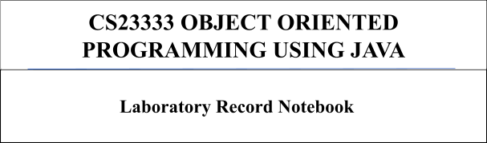

**Name :** MANO PRASAD V

**Year / Branch / Section** : 2ND YEAR / AIML / B **University Register No :** 2116231501095

**College Roll No :** 231501095

**Semester :** III

**Academic Year :** 2024 - 2025

[**Lab-01-Java Architecture, Language Basics**](http://www.rajalakshmicolleges.org/moodle/course/section.php?id=49)

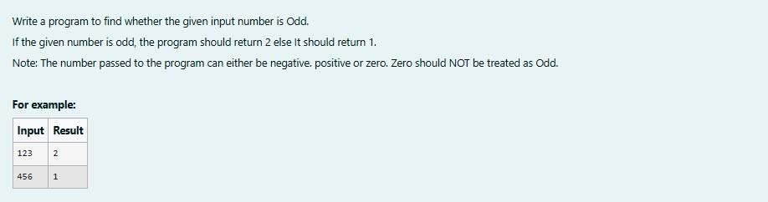1.

## SOLUTION :

import java.util.Scanner; public class oddorEven{

public static void main(String[]args){ Scanner s=new Scanner(System.in); int number = s.nextInt();

if(number %2==0){ System.out.println(1);

}

else {

System.out.println(2);

}

}

}

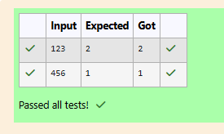**OUTPUT :**

## 2.

**SOLUTION :**

import java.util.Scanner; import java.lang.Math; public class LastDigit{

public static void main(String[]args){ Scanner s=new Scanner(System.in); int a = s.nextInt();

int lastDigit=Math.abs(a%10); System.out.println(lastDigit);

}

}

## OUTPUT :

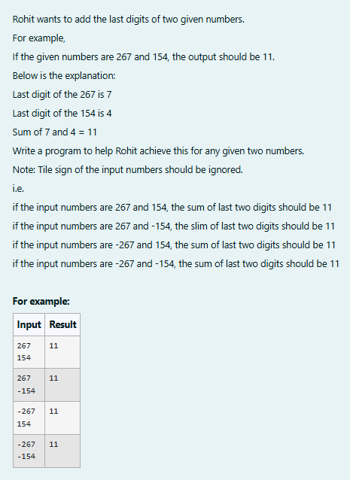**3.**

## SOLUTION :

import java.util.Scanner; import java.lang.Math; public class number{

public static void main(String[]args){ Scanner s= new Scanner(System.in); int a = s.nextInt();

int b = s.nextInt(); System.out.println(Math.abs(a)%10+Math.abs(b)%10);

}

}

**OUTPUT:**

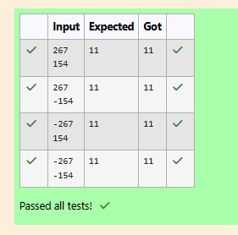

# [Lab-02-Flow Control Statements](http://www.rajalakshmicolleges.org/moodle/course/section.php?id=50)

## 1.

**SOLUTION :**

import java.util.Scanner;

public class SequenceGenerator{

public static void main(String[]args){ Scanner S = new Scanner(System.in); int n = S.nextInt();

String term = generateTerm(n); System.out.print(term);

}

private static String generateTerm(int n){ if (n==1){

return "1";

}

String prevTerm = generateTerm (n-1);

StringBuilder currentTerm = new StringBuilder(prevTerm);

## OUTPUT :

currentTerm.append(" " + n + " "); currentTerm.append(prevTerm); return currentTerm.toString();

}

}

**2.**

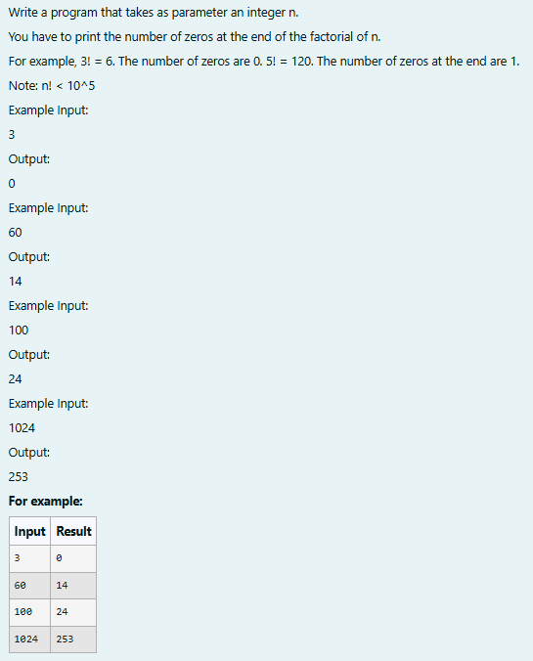

## SOLUTION :

// Java program to count trailing 0s in n! import java.io.*;

import java.util.Scanner; class prog {

// Function to return trailing

// 0s in factorial of n

static int findTrailingZeros(int n)

{

if (n < 0) // Negative Number Edge Case return -1;

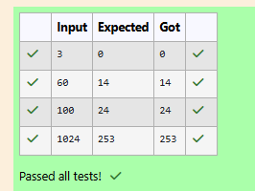**OUTPUT :**

// Initialize result

int count=0;

// Keep dividing n by powers

// of 5 and update count

for (int i = 5; n / i >= 1; i*=5 ){ count += n / i;

}

return count;

}

// Driver Code

public static void main(String[] args)

{

Scanner sc= new Scanner(System.in); int n=sc.nextInt();

int res=findTrailingZeros(n); System.out.println(res);

}

}

## 3.

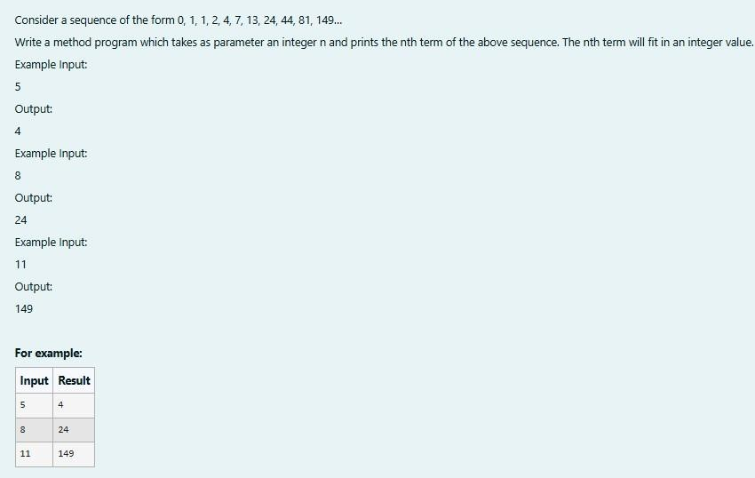

**SOLUTION :**

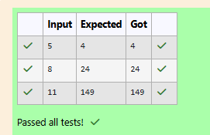**OUTPUT :**

import java.util.Scanner; class fibo3{

int a; int b; int c;

fibo3(int a,int b,int c){ this.a = a;

this.b = b; this.c = c;

}

int nth(int x){ if (x == 1){ return 0;

}

else if(x == 2 && x == 3) return 1;

else{

int temp1,temp2,temp; int count = 4;

while(x >= count){

temp = this.a+this.b+this.c; temp1 = this.c;

this.c = temp; temp2 = this.b; this.b = temp1; this.a = temp2; count++;

}

return this.c;

}

}

}

public class Main{

public static void main(String[] args){ Scanner s = new Scanner(System.in); int t = s.nextInt();

fibo3 r = new fibo3(0,1,1); System.out.print(r.nth(t));

}

}

# [Lab-03-Arrays](http://www.rajalakshmicolleges.org/moodle/course/section.php?id=51)

## 1.

**SOLUTION :**

import java.util.Scanner; public class digit{

public static void main(String[]args){ Scanner scanner =new Scanner(System.in);

## OUTPUT :

int size =scanner.nextInt(); int[]inpar=new int[size]; for(int i=0;i<size;i++){

inpar[i]=scanner.nextInt();

}

int[]dig=new int[size]; for(int i=0;i<size;i++){ int num=inpar[i];

if(i==0){ dig[i]=num%10;

}

else if (i==1){ dig[i]=(num/10)%10;

}

else if(i==2){ dig[i]=(num/100)%10;

}

else if(i==3){ dig[i]=(num/1000)%10;

}

else if(i==4){ dig[i]=(num/10000)%10;

}

else{

dig[i]=0;

}

}

int fin=0;

for(int digi:dig){ fin+=digi*digi;

}

System.out.print(fin);

}

}

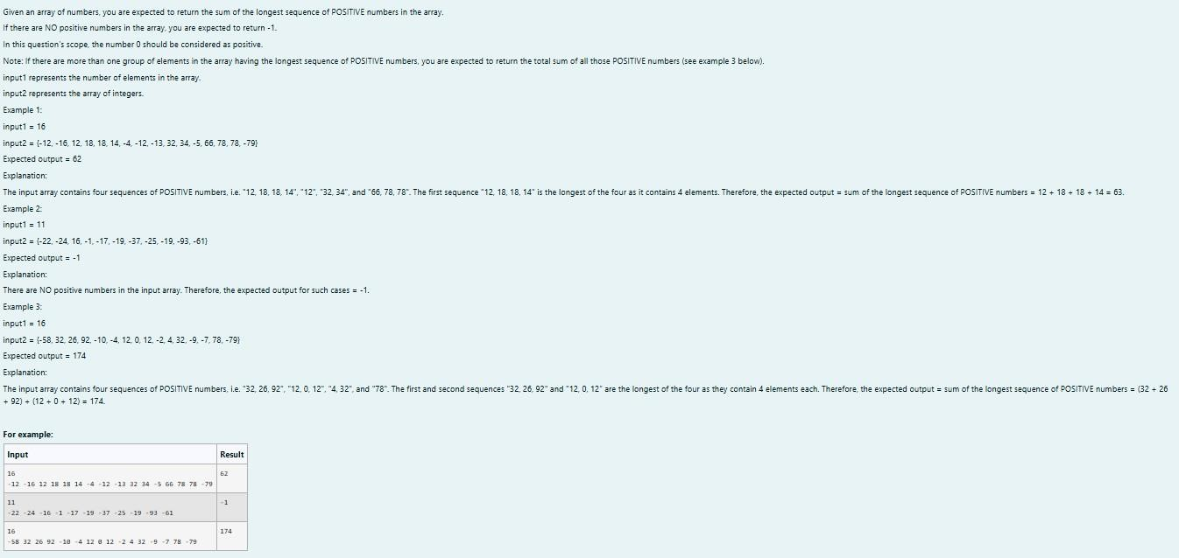**2.**

## SOLUTION :

import java.util.Scanner; public class longdig{

public static void main(String[]args){ Scanner sc=new Scanner(System.in); int n=sc.nextInt();

int c = 1,v,seqtemp = 0,seq = 0,countmax = 0; int count = 0;

while(c <= n){

v = sc.nextInt(); if(v >= 0){

countmax= countmax + v; seqtemp++;

}

else{

seqtemp = 0;

countmax = 0;

}

if(seqtemp > seq ){ seq = seqtemp; count = countmax;

}

else if (seq == seqtemp){ count = count + countmax;

} c++;

}

if (count == 0) System.out.print(-1);

else

System.out.print(count);

}

}

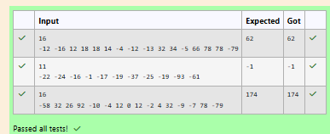**OUTPUT :**

## 3.

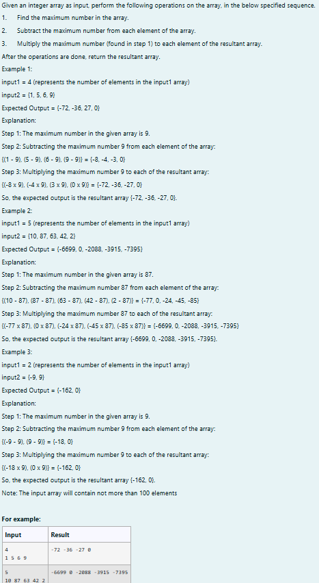

**SOLUTION :**

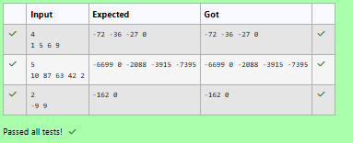**OUTPUT :**

import java.util.Scanner; public class res{

public static int[]pa(int[]arr){

int maxs=Integer.MIN_VALUE; for (int num:arr){

if(num>maxs){ maxs=num;

}

}

for(int i=0;i<arr.length;i++){ arr[i]=(arr[i]-maxs)*maxs;

}

return arr;

}

public static void main(String[]args){

Scanner scanner =new Scanner (System.in); int n=scanner.nextInt();

int[]arr=new int[n]; for(int i=0;i<n;i++){

arr[i]=scanner.nextInt();

}

int[]res=pa(arr); for(int i=0;i<n;i++){

System.out.print(res[i]+" ");

}

scanner.close();

}

}

# [Lab-04-Classes and Objects](http://www.rajalakshmicolleges.org/moodle/course/section.php?id=52)

## 1.

**SOLUTION :**

import java.io.*;

import java.util.Scanner; class Circle

{

private double radius;

public Circle(double radius){

// set the instance variable radius this.radius =radius;

}

public void setRadius(double radius){

// set the radius this.radius=radius;

}

public double getRadius() {

// return the radius return radius;

}

public double calculateArea() { // complete the below statement return Math.PI*radius*radius;

}

public double calculateCircumference() {

// complete the statement return 2*Math.PI*radius;

}

}

class prog{

public static void main(String[] args) { int r;

Scanner sc= new Scanner(System.in); r=sc.nextInt();

Circle c= new Circle(r);

System.out.println("Area = "+String.format("%.2f", c.calculateArea()));

// invoke the calculatecircumference method System.out.println("Circumference = "+String.format("%.2f" ,

c.calculateCircumference()));

sc.close();

}

}

## OUTPUT :

**2.**

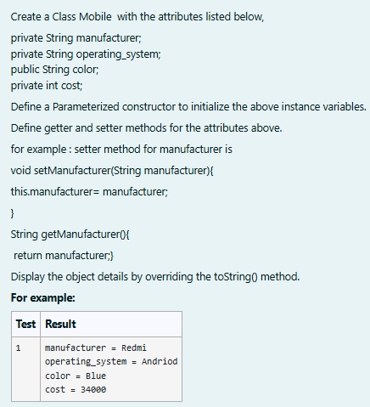

## SOLUTION :

public class mobile{ private String man; private String os; public String clr; private int cost;

public mobile(String man,String os,String clr,int cost){ this.man=man;

this.os=os; this.clr=clr; this.cost=cost;

}

public String toString(){

return "manufacturer = "+man+"\n"+"operating_system = "+os+"\n"+"color = "+ clr+"\n"+"cost = "+cost;

}

public static void main(String[]args){

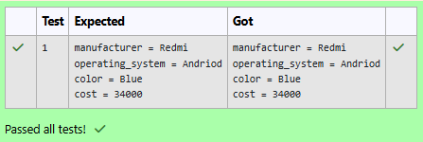**OUTPUT :**

mobile mobile=new mobile("Redmi","Andriod","Blue",34000); System.out.println(mobile);

}

}

## 3.

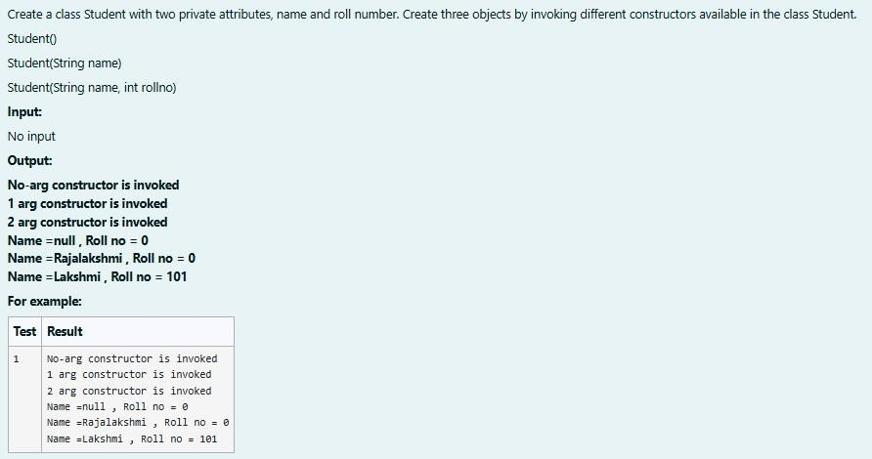

**SOLUTION :**

public class stud{ private String name; private int roll; public stud(){

System.out.println("No-arg constructor is invoked"); name=null;

roll=0;

}

public stud(String name){

System.out.println("1 arg constructor is invoked"); this.name=name;

roll=0;

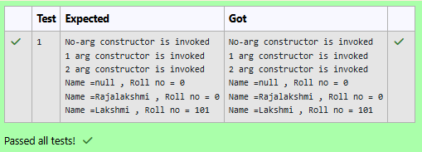**OUTPUT :**

}

public stud(String name,int roll){ System.out.println("2 arg constructor is invoked"); this.name=name;

this.roll=roll;

}

public static void main (String[]args){ stud s1=new stud();

stud s2=new stud("Rajalakshmi"); stud s3=new stud("Lakshmi",101);

System.out.println("Name ="+s1.name+" , Roll no = "+s2.roll); System.out.println("Name ="+s2.name+" , Roll no = "+s2.roll); System.out.println("Name ="+s3.name+" , Roll no = "+s3.roll);

}

}

# [Lab-05-Inheritance](http://www.rajalakshmicolleges.org/moodle/course/section.php?id=55)

## 1.

**SOLUTION :**

class BankAccount {

// Private field to store the account number private String accountNumber;

// Private field to store the balance

private double balance;

// Constructor to initialize account number and balance public BankAccount(String accountNumber,double balance){

this.accountNumber=accountNumber; this.balance=balance;

}

// Method to deposit an amount into the account public void deposit(double amount) {

// Increase the balance by the deposit amount balance+=amount;

}

// Method to withdraw an amount from the account public void withdraw(double amount) {

// Check if the balance is sufficient for the withdrawal if (balance >= amount) {

// Decrease the balance by the withdrawal amount balance -= amount;

} else {

// Print a message if the balance is insufficient System.out.println("Insufficient balance");

}

}

// Method to get the current balance public double getBalance() {

// Return the current balance return balance;

}

public String getAccountNumber(){ return accountNumber;

}

}

class SavingsAccount extends BankAccount {

// Constructor to initialize account number and balance

public SavingsAccount(String accountNumber, double balance) {

// Call the parent class constructor super(accountNumber,balance);

}

// Override the withdraw method from the parent class @Override

public void withdraw(double amount) {

// Check if the withdrawal would cause the balance to drop below $100

if (getBalance() - amount < 100) {

// Print a message if the minimum balance requirement is not met System.out.println("Minimum balance of $100 required!");

} else {

// Call the parent class withdraw method super.withdraw(amount);

}

}

}

public class Main {

public static void main(String[] args) {

// Print message to indicate creation of a BankAccount object System.out.println("Create a Bank Account object (A/c No. BA1234) with initial

balance of $500:");

// Create a BankAccount object (A/c No. "BA1234") with initial balance of $500 BankAccount BA1234 = new BankAccount("BA1234", 500);

// Print message to indicate deposit action System.out.println("Deposit $1000 into account BA1234:");

// Deposit $1000 into account BA1234 BA1234.deposit(1000);

// Print the new balance after deposit

System.out.println("New balance after depositing $1000: $"+BA1234.getBalance());

// Print message to indicate withdrawal action System.out.println("Withdraw $600 from account BA1234:");

// Withdraw $600 from account BA1234 BA1234.withdraw(600);

// Print the new balance after withdrawal System.out.println("New balance after withdrawing $600: $" +

BA1234.getBalance());

// Print message to indicate creation of another SavingsAccount object System.out.println("Create a SavingsAccount object (A/c No. SA1000) with initial

balance of $300:");

// Create a SavingsAccount object (A/c No. "SA1000") with initial balance of $300 SavingsAccount SA1000 = new SavingsAccount("SA1000", 300);

// Print message to indicate withdrawal action System.out.println("Try to withdraw $250 from SA1000!");

// Withdraw $250 from SA1000 (balance falls below $100) SA1000.withdraw(250);

// Print the balance after attempting to withdraw $250 System.out.println("Balance after trying to withdraw $250: $" +

SA1000.getBalance());

}

}

## OUTPUT :

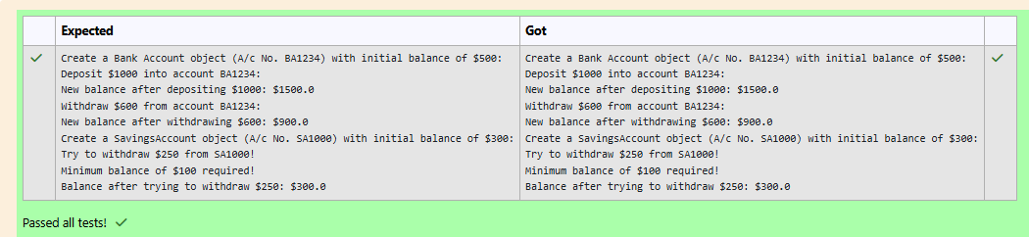

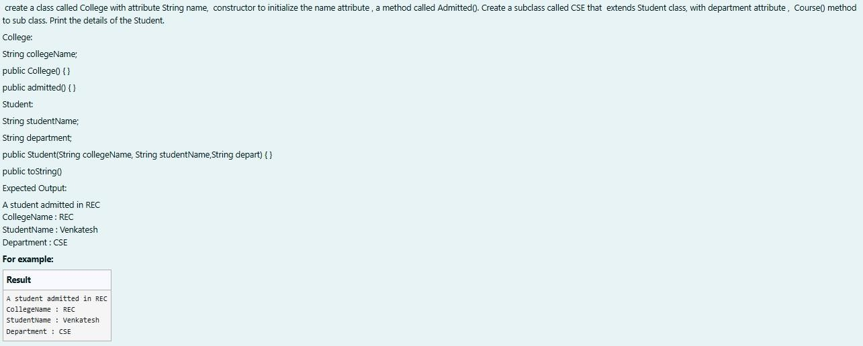**2.**

## SOLUTION :

class College

{

public String collegeName;

public College(String collegeName) {

// initialize the instance variables this.collegeName=collegeName;

}

public void admitted() {

System.out.println("A student admitted in "+collegeName);

}

}

class Student extends College{

String studentName;

String department;

public Student(String collegeName, String studentName,String department) {

// initialize the instance variables super(collegeName); this.studentName=studentName; this.department=department;

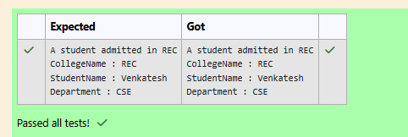**OUTPUT :**

}

public String toString(){

// return the details of the student

return "CollegeName : "+collegeName+"\n"+"StudentName : "+studentName+"\n"+"Department : "+department;

}

}

public class Main {

public static void main (String[] args) {

Student s1 = new Student("REC","Venkatesh","CSE"); s1.admitted(); // invoke the admitted() method System.out.println(s1.toString());

}

}

## 3.

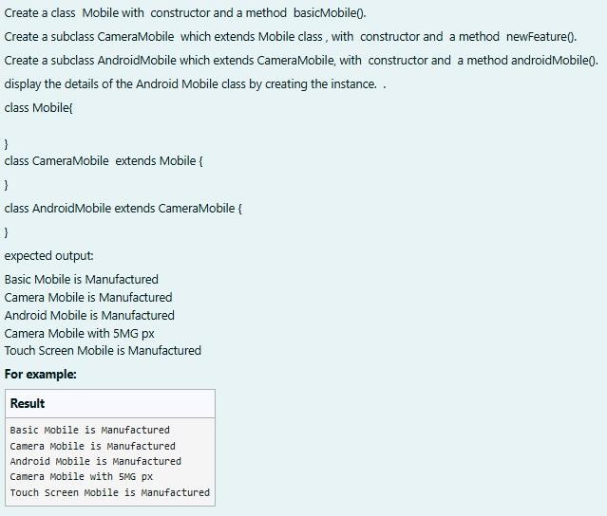

**SOLUTION :**

class mob{ mob(){

System.out.println("Basic Mobile is Manufactured");

}

void basmob(){

System.out.println("Basic Mobile is Manufactured");

}

}

class cam extends mob{ cam(){

super();

System.out.println("Camera Mobile is Manufactured");

}

void newm(){

System.out.println("Camera Mobile with 5MG px");

}

}

class and extends cam{ and(){

super();

System.out.println("Android Mobile is Manufactured");

}

void andmob(){

System.out.println("Touch Screen Mobile is Manufactured");

}

}

public class Main{

public static void main(String[]args){ and andmob=new and(); andmob.newm(); andmob.andmob();

}

}

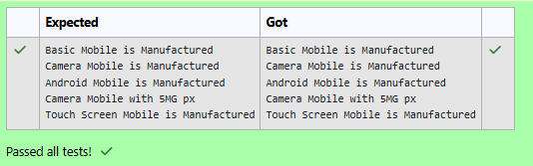**OUTPUT :**

# [Lab-06-String, StringBuffer](http://www.rajalakshmicolleges.org/moodle/course/section.php?id=54)

## 1.

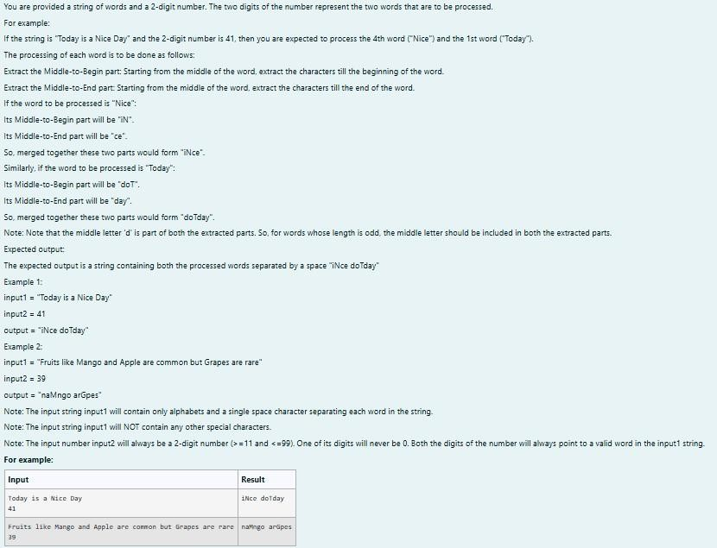

**SOLUTION :**

import java.util.*; public class mix{

public static void main(String[] args){ Scanner scan = new Scanner(System.in); String g = scan.nextLine();

int n = scan.nextInt(),ones,flag = 0; StringBuffer temp = new StringBuffer(); StringBuffer temp1 = new StringBuffer(); int space = 0;

while (n > 0){

ones = (n %10) - 1;

for(int i = 0; i < g.length();i++){ if (g.charAt(i) == ' '){

space = space + 1;

}

else if(space == ones && flag == 0){ temp.append(Character.toString(g.charAt(i)));

}

else if(space == ones && flag == 1){ temp1.append(Character.toString(g.charAt(i)));

}

## OUTPUT :

}

space = 0 ; flag = 1;

n = n /10;

}

rew m = new rew();

System.out.println(m.r(temp1.toString()) + " " + m.r(temp.toString()));

}

}

class rew{

String r(String a){

int le = a.length(),n,q;

StringBuffer temp3 = new StringBuffer(); if(le % 2 == 1){

n = ((int)(le/2));

q = ((int)(le/2));

}

else{

n = ((int)(le/2)) - 1;

q = ((int)(le/2));

}

for(int i = n;i >= 0;i--){ temp3.append(Character.toString(a.charAt(i)));

}

for(int i = q;i < le;i++){ temp3.append(Character.toString(a.charAt(i)));

}

return temp3.toString();

}

}

**2.**

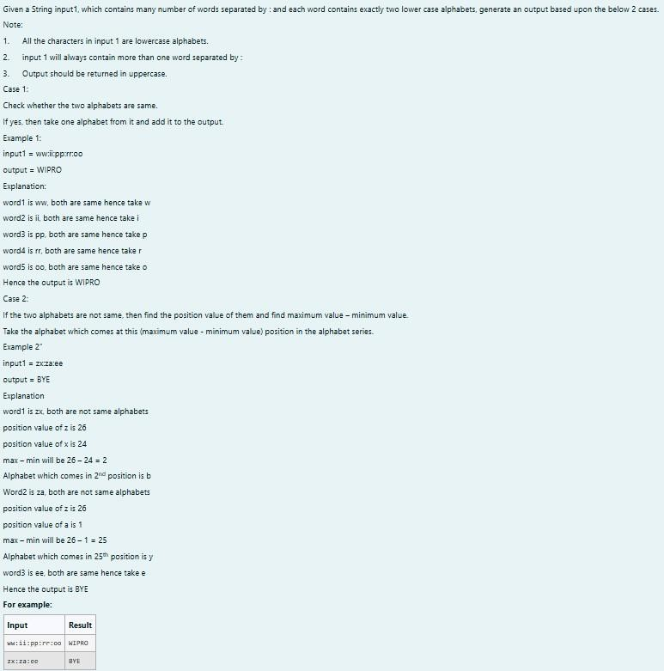

## SOLUTION :

import java.util.*; class diff{

char different(char a, char b){ if ((int)a != (int)b)

return (char)((int)'a' + ((int)a-(int)b) - 1); return a;

}

}

public class Main{

public static void main(String[] args){ Scanner scan = new Scanner(System.in); diff z = new diff();

String q = scan.nextLine(); StringBuffer ans = new StringBuffer();

StringBuffer temp = new StringBuffer(); for(int i = 0;i < q.length();i++){

if(q.charAt(i) == ':'){ temp.append(" ");

}

else{

temp.append(Character.toString(q.charAt(i)));

}

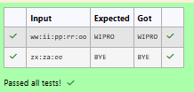**OUTPUT :**

}

String h = temp.toString();

for(int i = 0;i < temp.length();i++){ if(i%3 == 0){

ans.append(Character.toString(z.different(h.charAt(i),h.charAt(i+1))));

}

}

System.out.print(ans.toString().toUpperCase());

}

}

## 3.

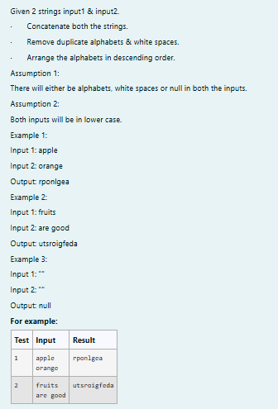

**SOLUTION :**

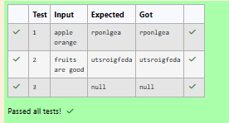**OUTPUT :**

import java.util.*;

public class HelloWorld {

public static void main(String[] args) { Scanner scan = new Scanner(System.in); String a = scan.nextLine();

String b = scan.nextLine(); StringBuffer ab = new StringBuffer();

if(a.trim().isEmpty() && b.trim().isEmpty()){ System.out.print("null");

}

else{

for(int i = 0;i < a.length();i++){ if (a.charAt(i) != ' ') {

ab.append(Character.toString(a.charAt(i)));

}

}

for(int i = 0;i < b.length();i++){ if (b.charAt(i) != ' '){

ab.append(Character.toString(b.charAt(i)));

}

}

char[] d = ab.toString().toCharArray(); Arrays.sort(d);

for(int i = d.length - 1;i >= 1;i--){ if(d[i] != d[i-1])

System.out.print(d[i]);

}

System.out.print(d[0]);

}

}

}

# [Lab-07-Interfaces](http://www.rajalakshmicolleges.org/moodle/course/section.php?id=58)

## 1.

**SOLUTION :**

// Define the RBI interface interface RBI {

// Variable declaration String parentBank = "RBI";

// Abstract method double rateOfInterest();

// Default method

default void policyNote() {

System.out.println("RBI has a new Policy issued in 2023");

}

// Static method

static void regulations() {

System.out.println("RBI has updated new regulations in 2024.");

}

}

// SBI class implementing RBI interface class SBI implements RBI {

// Implementing the abstract method public double rateOfInterest() {

## OUTPUT :

return 7.6;

}

}

// Karur class implementing RBI interface class Karur implements RBI {

// Implementing the abstract method public double rateOfInterest() {

return 7.4;

}

}

// Main class to test the functionality public class Main {

public static void main(String[] args) {

// RBI policies and regulations

RBI rbi = new SBI(); // Can be any class implementing RBI rbi.policyNote(); // Default method

RBI.regulations(); // Static method

// SBI bank details SBI sbi = new SBI();

System.out.println("SBI rate of interest: " + sbi.rateOfInterest() + " per annum.");

// Karur bank details

Karur karur = new Karur();

System.out.println("Karur rate of interest: " + karur.rateOfInterest() + " per annum.");

}

}

**2.**

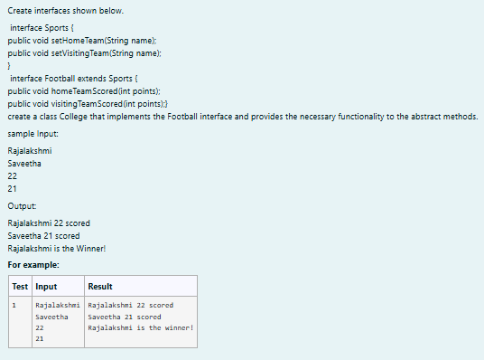

## SOLUTION :

import java.util.Scanner;

interface Sports {

void setHomeTeam(String name); void setVisitingTeam(String name);

}

interface Football extends Sports { void homeTeamScored(int points); void visitingTeamScored(int points);

}

class College implements Football { private String homeTeam;

private String visitingTeam; private int homeTeamPoints = 0; private int visitingTeamPoints = 0;

public void setHomeTeam(String name) { this.homeTeam = name;

}

public void setVisitingTeam(String name) { this.visitingTeam = name;

}

public void homeTeamScored(int points) {

homeTeamPoints += points; System.out.println(homeTeam + " " + points + " scored");

}

public void visitingTeamScored(int points) { visitingTeamPoints += points; System.out.println(visitingTeam + " " + points + " scored");

}

public void winningTeam() {

if (homeTeamPoints > visitingTeamPoints) { System.out.println(homeTeam + " is the winner!");

} else if (homeTeamPoints < visitingTeamPoints) { System.out.println(visitingTeam + " is the winner!");

} else {

System.out.println("It's a tie match.");

}

}

}

public class Main {

public static void main(String[] args) { Scanner sc = new Scanner(System.in);

// Get home team name String hname = sc.nextLine();

// Get visiting team name String vteam = sc.nextLine();

// Create College object

College match = new College(); match.setHomeTeam(hname); match.setVisitingTeam(vteam);

// Get points scored by home team int htpoints = sc.nextInt(); match.homeTeamScored(htpoints);

// Get points scored by visiting team int vtpoints = sc.nextInt(); match.visitingTeamScored(vtpoints);

// Determine and print the winning team match.winningTeam();

sc.close();

}

}

## OUTPUT :

**3.**

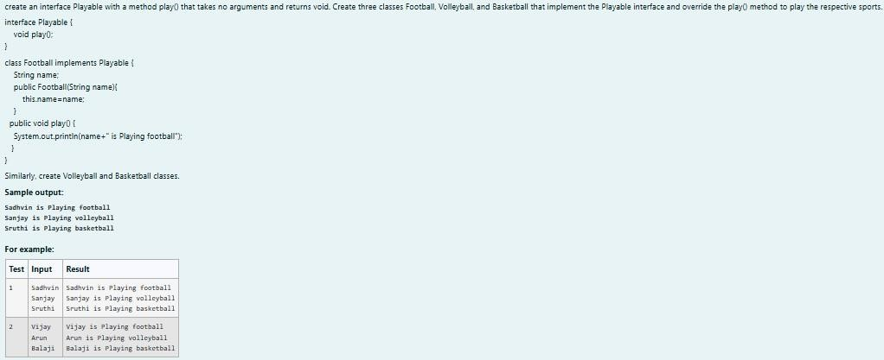

## SOLUTION :

import java.util.Scanner;

// Define the Playable interface interface Playable {

// Abstract method to play the respective sport void play();

}

// Football class implementing Playable interface class Football implements Playable {

String name;

// Constructor

public Football(String name) { this.name = name;

}

// Override the play method

public void play() {

System.out.println(name + " is Playing football");

}

}

// Volleyball class implementing Playable interface class Volleyball implements Playable {

String name;

// Constructor

public Volleyball(String name) { this.name = name;

}

// Override the play method public void play() {

System.out.println(name + " is Playing volleyball");

}

}

// Basketball class implementing Playable interface class Basketball implements Playable {

String name;

// Constructor

public Basketball(String name) { this.name = name;

}

// Override the play method public void play() {

System.out.println(name + " is Playing basketball");

}

}

// Main class to test the functionality public class Main {

public static void main(String[] args) { Scanner scanner = new Scanner(System.in);

// Input for Football player

String footballPlayerName = scanner.nextLine();

Football footballPlayer = new Football(footballPlayerName);

// Input for Volleyball player

String volleyballPlayerName = scanner.nextLine();

Volleyball volleyballPlayer = new Volleyball(volleyballPlayerName);

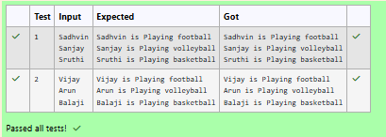**OUTPUT :**

// Input for Basketball player

String basketballPlayerName = scanner.nextLine();

Basketball basketballPlayer = new Basketball(basketballPlayerName);

// Call the play method for each player footballPlayer.play(); volleyballPlayer.play(); basketballPlayer.play();

scanner.close();

}

}

# [Lab-08 - Polymorphism, Abstract Classes, final Keyword](http://www.rajalakshmicolleges.org/moodle/course/section.php?id=57)

## 1.

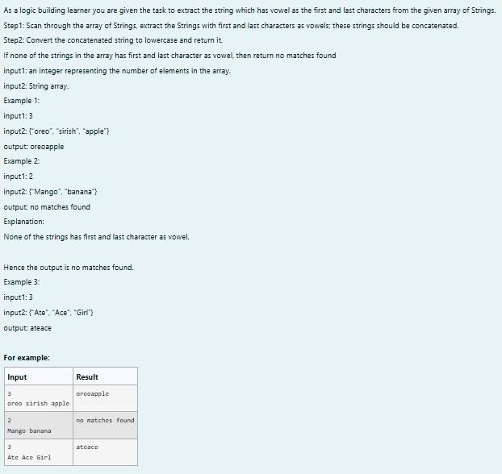

**SOLUTION :**

import java.util.Scanner;

public class VowelStringExtractor {

// Method to extract strings with vowels as first and last characters public static String extractVowelStrings(String[] stringArray) {

StringBuilder result = new StringBuilder();

String vowels = "aeiouAEIOU"; // String containing all vowels

// Iterate through the array of strings for (String s : stringArray) {

// Check if the string is not empty and if both the first and last characters are vowels if (s.length() > 0 && vowels.indexOf(s.charAt(0)) != -1 &&

vowels.indexOf(s.charAt(s.length() - 1)) != -1) { result.append(s); // Append matching string to the result

}

}

// Return the concatenated string in lowercase or "no matches found"

return result.length() > 0 ? result.toString().toLowerCase() : "no matches found";

}

## OUTPUT :

public static void main(String[] args) { Scanner scanner = new Scanner(System.in);

// Input for the number of strings int n = scanner.nextInt();

scanner.nextLine(); // Consume the newline character

// Input for the strings in one line String input = scanner.nextLine();

String[] strings = input.split(" "); // Split input into an array

// Process and output the result

String result = extractVowelStrings(strings); System.out.println(result);

scanner.close(); // Close the scanner

}

}

**2.**

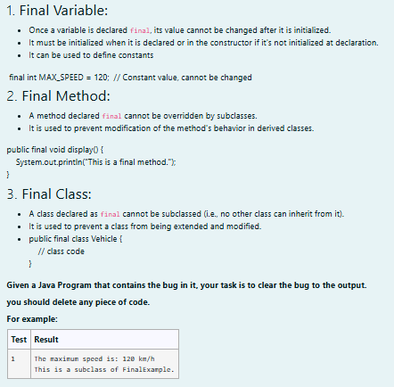

## SOLUTION :

// Final class definition final class FinalExample {

// Final variable

final int MAX_SPEED = 120; // Constant value

// Final method

public final void display() {

System.out.println("The maximum speed is: " + MAX_SPEED + " km/h");

}

}

// Main class to test the final class public class Test {

public static void main(String[] args) {

// Create an instance of FinalExample FinalExample example = new FinalExample(); example.display();

// Uncommenting the following line will result in a compile-time error

// because FinalExample is a final class and cannot be subclassed.

// class SubclassExample extends FinalExample { }

System.out.println("This is a subclass of FinalExample.");

}

}

**OUTPUT :**

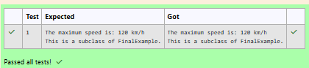

## 3.

**SOLUTION :**

import java.util.Scanner;

// Abstract class Shape abstract class Shape {

public abstract double calculateArea();

}

// Circle class

class Circle extends Shape { private double radius;

public Circle(double radius) { this.radius = radius;

}

@Override

public double calculateArea() {

return Math.PI * radius * radius; // Area of circle: πr²

}

}

// Rectangle class

class Rectangle extends Shape { private double length;

private double breadth;

public Rectangle(double length, double breadth) { this.length = length;

this.breadth = breadth;

}

@Override

public double calculateArea() {

return length * breadth; // Area of rectangle: length * breadth

}

}

// Triangle class

class Triangle extends Shape { private double base;

private double height;

public Triangle(double base, double height) { this.base = base;

this.height = height;

}

@Override

public double calculateArea() {

return 0.5 * base * height; // Area of triangle: 0.5 * base * height

}

}

// Main class to test the shapes public class ShapeTest {

public static void main(String[] args) { Scanner scanner = new Scanner(System.in);

// Input for Circle

double radius = scanner.nextDouble(); Circle circle = new Circle(radius);

System.out.printf("Area of a circle: %.2f%n", circle.calculateArea());

// Input for Rectangle

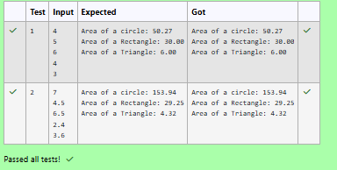**OUTPUT :**

double length = scanner.nextDouble(); double breadth = scanner.nextDouble();

Rectangle rectangle = new Rectangle(length, breadth); System.out.printf("Area of a Rectangle: %.2f%n", rectangle.calculateArea());

// Input for Triangle

double base = scanner.nextDouble(); double height = scanner.nextDouble();

Triangle triangle = new Triangle(base, height);

System.out.printf("Area of a Triangle: %.2f%n", triangle.calculateArea());

scanner.close();

}

}

# [Lab-09-Exception Handling](http://www.rajalakshmicolleges.org/moodle/course/section.php?id=59)

## 1.

**SOLUTION :**

class prog {

public static void main(String[] args) {

## OUTPUT :

int n = 82; trynumber(n); n = 37;

trynumber(n); // Call the trynumber(n);

}

public static void trynumber(int n) { try {

checkEvenNumber(n); // Call the checkEvenNumber() System.out.println(n + " is even.");

} catch (Exception e) { // Catch the exception System.out.println("Error: " + e.getMessage());

}

}

public static void checkEvenNumber(int number) { if (number % 2 != 0) {

throw new RuntimeException(number + " is odd."); // Throw a RuntimeException

}

**}**

**}**

**2.**

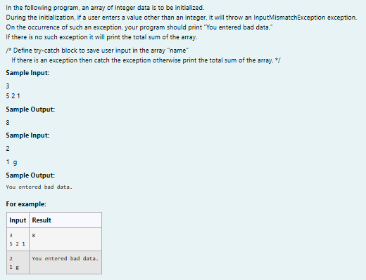

## SOLUTION :

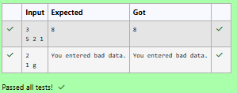**OUTPUT :**

import java.util.Scanner;

import java.util.InputMismatchException;

class prog {

public static void main(String[] args) { Scanner sc = new Scanner(System.in); int length = sc.nextInt();

// create an array to save user input int[] name = new int[length];

int sum = 0; // save the total sum of the array.

/* Define try-catch block to save user input in the array "name" If there is an exception then catch the exception otherwise print the total sum of the array. */

try {

for (int i = 0; i < length; i++) {

name[i] = sc.nextInt(); // save user input in the array

}

// Calculate the total sum for (int num : name) {

sum += num;

}

// Print the total sum System.out.println(sum);

} catch (InputMismatchException e) { System.out.println("You entered bad data.");

}

sc.close(); // Close the scanner

}

}

## 3.

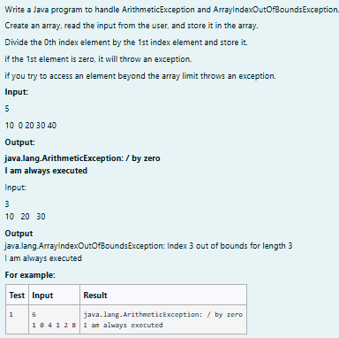

**SOLUTION :**

import java.util.Scanner;

public class ExceptionHandlingExample { public static void main(String[] args) {

Scanner scanner = new Scanner(System.in);

// Read the size of the array int size = scanner.nextInt();

// Initialize the array

int[] numbers = new int[size];

// Read the elements into the array for (int i = 0; i < size; i++) {

numbers[i] = scanner.nextInt();

}

try {

// Attempt to perform division

int result = numbers[0] / numbers[1]; // This may cause an ArithmeticException

} catch (ArithmeticException e) { System.out.println(e); // Catch division by zero

} catch (ArrayIndexOutOfBoundsException e) { System.out.println(e); // Catch accessing out of bounds

} catch (Exception e) {

System.out.println(e); // Catch any other exceptions

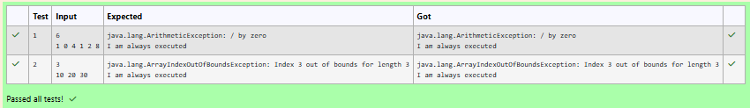**OUTPUT :**

} finally {

// This block is always executed

}

try {

// Attempt to access an out-of-bounds index

int outOfBoundsValue = numbers[3]; // This will trigger ArrayIndexOutOfBoundsException if size < 4

} catch (ArrayIndexOutOfBoundsException e) { System.out.println(e);

} finally {

// This block is always executed for the second try System.out.println("I am always executed");

}

scanner.close();

}

}

# [Lab-10- Collection- List](http://www.rajalakshmicolleges.org/moodle/course/section.php?id=60)

## 1.

**SOLUTION :**

import java.util.ArrayList; import java.util.Scanner;

public class FirstAndLastElement { public static void main(String[] args) {

Scanner scanner = new Scanner(System.in);

// Create an ArrayList

ArrayList<Integer> numbers = new ArrayList<>();

## OUTPUT :

int numElements = scanner.nextInt();

for (int i = 0; i < numElements; i++) { int number = scanner.nextInt(); numbers.add(number);

}

System.out.println("ArrayList: " + numbers);

// Get the first element

int firstElement = numbers.get(0);

// Get the last element

int lastElement = numbers.get(numbers.size() - 1);

// Print the results

System.out.print("First : " + firstElement); System.out.println(", Last : " + lastElement);

}

}

**2.**

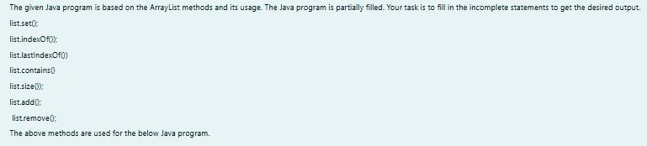

## SOLUTION :

import java.util.ArrayList; import java.util.Scanner;

public class Prog {

public static void main(String[] args)

{

Scanner sc= new Scanner(System.in); int n = sc.nextInt();

ArrayList<Integer> list = new ArrayList<Integer>(); for(int i = 0; i<n;i++)

list.add(sc.nextInt());

// printing initial value ArrayList System.out.println("ArrayList: " + list);

//Replacing the element at index 1 with 100 list.set(1,100);

//Getting the index of first occurrence of 100 System.out.println("Index of 100 = "+ list.indexOf(100)

);

//Getting the index of last occurrence of 100 System.out.println("LastIndex of 100 = "+ list.lastIndexOf(100));

// Check whether 200 is in the list or not System.out.println(list.contains(200)); //Output : false

// Print ArrayList size

System.out.println("Size Of ArrayList = "+list.size() );

//Inserting 500 at index 1

list.add(1,500); // code here

//Removing an element from position 3 list.remove(3); // code here System.out.print("ArrayList: " + list);

}

}

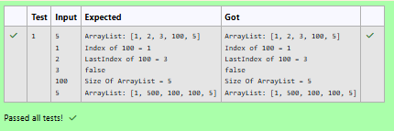**OUTPUT :**

## 3.

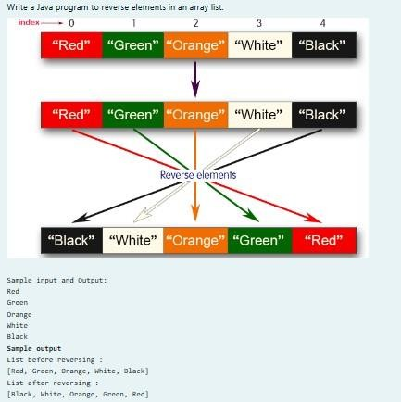

**SOLUTION :**

import java.util.ArrayList; import java.util.Collections; import java.util.Scanner;

public class ReverseArrayList {

public static void main(String[] args) { Scanner scanner = new Scanner(System.in);

ArrayList<String> list = new ArrayList<>(); int n = scanner.nextInt();

for (int i = 0; i < n; i++) {

String element = scanner.next(); list.add(element);

}

System.out.println("List before reversing : "); System.out.println(list);

Collections.reverse(list);

System.out.println("List after reversing : "); System.out.println(list);

}

}

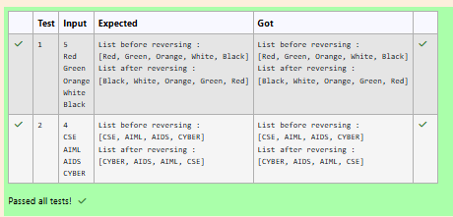**OUTPUT :**

# [Lab-11-Set, Map](http://www.rajalakshmicolleges.org/moodle/course/section.php?id=61)

## 1.

**SOLUTION :**

**import java.util.HashSet; import java.util.Scanner;**

**public class Prog {**

**public static void main(String[] args) { Scanner sc = new Scanner(System.in);**

**// Read the number of elements int n = sc.nextInt();**

## OUTPUT :

**// Create a HashSet object to store numbers HashSet<Integer> numbers = new HashSet<>();**

**// Add numbers to the HashSet for (int i = 0; i < n; i++) {**

**numbers.add(sc.nextInt());**

**}**

**// Read the search key int skey = sc.nextInt();**

**// Check if skey is present in the HashSet if (numbers.contains(skey)) {**

**System.out.println(skey + " was found in the set.");**

**} else {**

**System.out.println(skey + " was not found in the set.");**

**}**

**// Close the scanner sc.close();**

**}**

**}**

**2.**

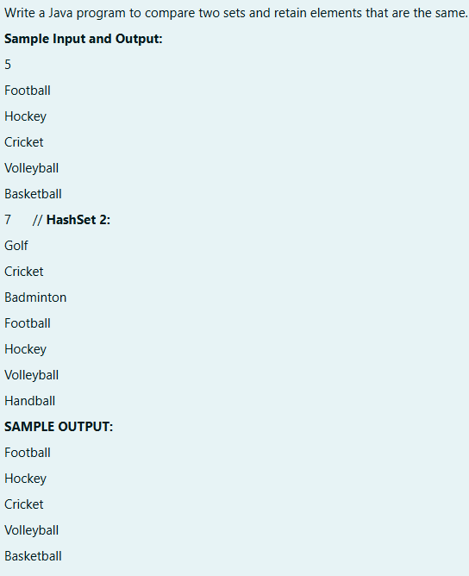

## SOLUTION :

**import java.util.HashSet; import java.util.Scanner; import java.util.Set;**

**public class CompareSets {**

**public static void main(String[] args) { Scanner scanner = new Scanner(System.in);**

**// Read the size of the first set**

**int size1 = Integer.parseInt(scanner.nextLine());**

**// Create a HashSet to store the first set of elements Set<String> set1 = new HashSet<>();**

**// Read elements for the first set for (int i = 0; i < size1; i++) {**

**set1.add(scanner.nextLine());**

**}**

**// Read the size of the second set**

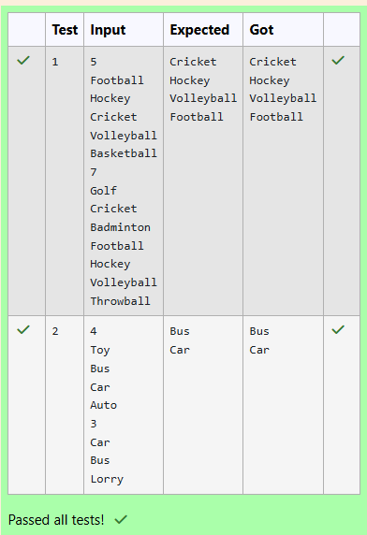**OUTPUT :**

**int size2 = Integer.parseInt(scanner.nextLine());**

**// Create a HashSet to store the second set of elements Set<String> set2 = new HashSet<>();**

**// Read elements for the second set for (int i = 0; i < size2; i++) {**

**set2.add(scanner.nextLine());**

**}**

**// Retain common elements using the retainAll() method set1.retainAll(set2);**

**// Print the common elements for (String element : set1) {**

**System.out.println(element);**

**}**

**scanner.close();**

**}**

**}**

## 3.

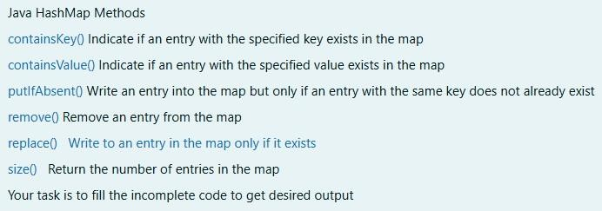

**SOLUTION :**

**import java.util.HashMap; import java.util.Map.Entry; import java.util.Scanner; import java.util.Set;**

**public class Prog {**

**public static void main(String[] args) {**

**// Creating HashMap with default initial capacity and load factor HashMap<String, Integer> map = new HashMap<String, Integer>();**

**String name; int num;**

**Scanner sc = new Scanner(System.in); int n = sc.nextInt();**

**for (int i = 0; i < n; i++) { name = sc.next();**

**num = sc.nextInt(); map.put(name, num);**

**}**

**// Printing key-value pairs**

**Set<Entry<String, Integer>> entrySet = map.entrySet();**

**for (Entry<String, Integer> entry : entrySet) { System.out.println(entry.getKey() + " : " + entry.getValue());**

**}**

**System.out.println(" ");**

**// Creating another HashMap**

**HashMap<String, Integer> anotherMap = new HashMap<String, Integer>();**

**// Inserting key-value pairs to anotherMap using put() method anotherMap.put("SIX", 6);**

## anotherMap.put("SEVEN", 7);

**// Inserting key-value pairs of map to anotherMap using putAll() method anotherMap.putAll(map); // This line fills in the missing code**

## // Printing key-value pairs of anotherMap entrySet = anotherMap.entrySet();

**for (Entry<String, Integer> entry : entrySet) { System.out.println(entry.getKey() + " : " + entry.getValue());**

## }

**// Adds key-value pair 'FIVE-5' only if it is not present in map map.putIfAbsent("FIVE", 5);**

## // Retrieving a value associated with key 'TWO' int value = map.get("TWO");

**System.out.println(value); // Prints the value associated with key "TWO" (if it exists)**

## // Checking whether key 'ONE' exists in map System.out.println(map.containsKey("ONE")); // Prints true if "ONE" is a key,

**false otherwise**

## // Checking whether value '3' exists in map

**boolean valueExists = map.containsValue(3); // You can use a variable to store the result**

## System.out.println(valueExists); // Prints true if value 3 exists in the map, false otherwise

**// Retrieving the number of key-value pairs present in map System.out.println(map.size()); // Prints the number of entries in the map**

## }

**}**

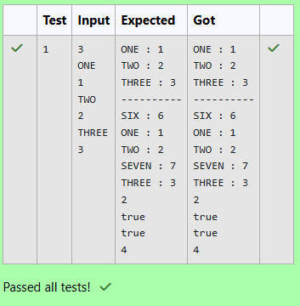**OUTPUT :**

# [Lab-12-Introduction to I/O, I/O Operations, Object](http://www.rajalakshmicolleges.org/moodle/course/section.php?id=56) [Serialization](http://www.rajalakshmicolleges.org/moodle/course/section.php?id=56)

## 1.

**SOLUTION :**

**import java.util.Scanner;**

**public class DecodeString {**

**public static void main(String[] args) { Scanner scanner = new Scanner(System.in); String encodedString = scanner.nextLine();**

**StringBuilder decodedString = new StringBuilder(); int count = 0;**

**for (int i = 0; i < encodedString.length(); i++) { if (encodedString.charAt(i) == '0') {**

**count++;**

**} else {**

**char decodedChar = (char) ('Z' - count + 1); decodedString.append(decodedChar); count = 0;**

**}**

**}**

**System.out.println(decodedString.toString());**

**}**

## OUTPUT :

**}**

**2.**

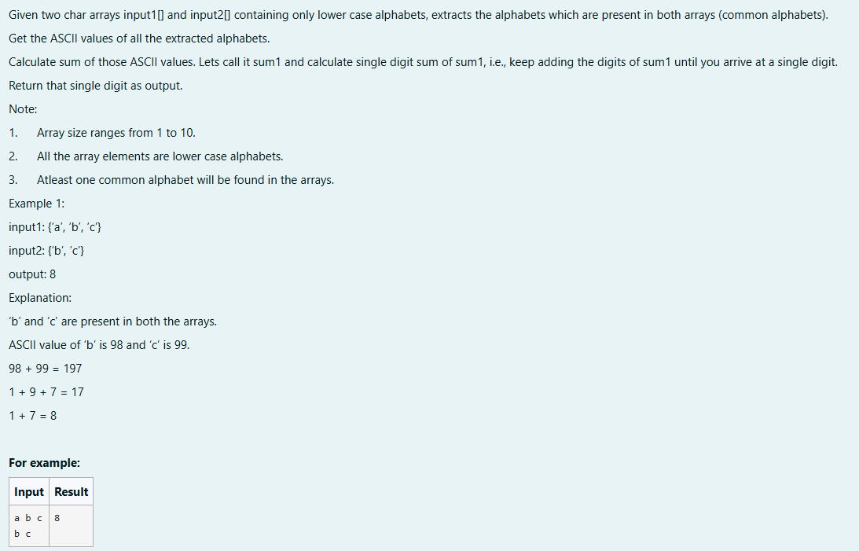

## SOLUTION :

**import java.util.HashSet; import java.util.Set;**

**public class CommonAlphabetSum {**

**public static int singleDigitSum(int num) { int sum = 0;**

**while (num > 0) { sum += num % 10; num /= 10;**

**}**

**if (sum > 9) {**

**return singleDigitSum(sum);**

**}**

**return sum;**

**}**

**public static int calculateCommonAlphabetSum(char[] input1, char[] input2) { Set<Character> set1 = new HashSet<>();**

**for (char c : input1) { set1.add(c);**

**}**

**int sum = 0;**

**for (char c : input2) { if (set1.contains(c)) {**

**sum += c;**

**}**

**}**

**return singleDigitSum(sum);**

**}**

**public static void main(String[] args) { char[] input1 = {'a', 'b', 'c'};**

**char[] input2 = {'b', 'c', 'd'};**

**int result = calculateCommonAlphabetSum(input1, input2); System.out.println(result);**

**}**

**}**

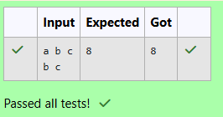**OUTPUT :**

## 3.

**SOLUTION :**

**import java.util.Scanner; public class WordReverser {**

**public static String reverseWordsWithCase(String sentence, int caseOption) {**

**// Split the sentence into words based on spaces String[] words = sentence.split(" ");**

**// StringBuilder to store the result StringBuilder result = new StringBuilder();**

**// Process each word**

**for (String word : words) {**

**// Reverse the word**

**String reversedWord = new StringBuilder(word).reverse().toString();**

**if (caseOption == 0) {**

**// If caseOption is 0, no case conversion, just reverse the word result.append(reversedWord).append(" ");**

**} else if (caseOption == 1) {**

**// If caseOption is 1, adjust the case while maintaining original letter**

**positions**

## result.append(applyCaseConversion(reversedWord, word)).append(" ");

**}**

## }

**// Remove the trailing space and return the result return result.toString().trim();**

## }

**private static String applyCaseConversion(String reversedWord, String originalWord) {**

## // StringBuilder to store the adjusted word StringBuilder adjustedWord = new StringBuilder();

**// Iterate over each character in the reversed word for (int i = 0; i < reversedWord.length(); i++) {**

## char reversedChar = reversedWord.charAt(i); char originalChar = originalWord.charAt(i);

**if (Character.isLowerCase(originalChar)) {**

## // If the original character was lowercase, the reversed character should be uppercase

**adjustedWord.append(Character.toLowerCase(reversedChar));**

## } else if (Character.isUpperCase(originalChar)) {

**// If the original character was uppercase, the reversed character should be lowercase**

## adjustedWord.append(Character.toUpperCase(reversedChar));

**} else {**

## // Non-alphabetic characters remain unchanged adjustedWord.append(reversedChar);

**}**

## }

**return adjustedWord.toString();**

## }

**public static void main(String[] args) {**

## // Create a Scanner object to get input from the user Scanner scanner = new Scanner(System.in);

**// Get sentence input from the user String sentence = scanner.nextLine();**

## // Get case option input from the user int caseOption = scanner.nextInt();

**// Validate the case option**

## if (caseOption != 0 && caseOption != 1) {

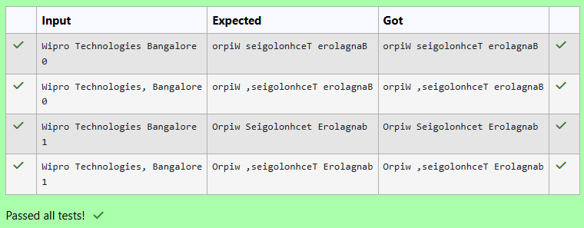**OUTPUT :**

**System.out.println("Invalid case option. Please enter 0 or 1.");**

**} else {**

**// Call the function and print the result**

**String result = reverseWordsWithCase(sentence, caseOption); System.out.println(result);**

**}**

**// Close the scanner scanner.close();**

**}**

**}**